Mohammed Numaan Ahmed
2503B05127
Assignment-8
Q1. A process is a program in execution. In real CPU scheduling, processes do not always arrive at the same time.
The First Come First Serve (FCFS) algorithm schedules processes in order of arrival time.
Requirements:
- The program should accept:
  - Number of processes
  - Arrival Time (AT)
  - Burst Time (BT)
- The program must sort the processes in ascending order of arrival time.
- The CPU may become idle if the next process arrives later. Your logic must correctly handle idle time.
- Calculate for each process:
  - Completion Time (CT)
  - Turnaround Time (TAT = CT – AT)
  - Waiting Time (WT = TAT – BT)
- Display the result in a formatted table and print:
  - Total TAT and WT
  - Average TAT and WT
- Use non-preemptive FCFS.
Given System State
Consider the following processes:
Process | Arrival Time | CPU Burst Time
P1 | 2 | 4
P2 | 1 | 3
P3 | 0 | 1
P4 | 3 | 2

Code:
// FCFS CPU Scheduling with Arrival Time and Idle Handling
#include <stdio.h>
int main() {
int n, i, j;
printf("Enter number of processes: ");
scanf("%d", &n);
int pid[n], at[n], bt[n];
int ct[n], tat[n], wt[n];
float avg_tat = 0, avg_wt = 0;
int total_tat = 0, total_wt = 0;

// Input
for (i = 0; i < n; i++) {
printf("Enter Process ID, Arrival Time and Burst Time for process %d: ", i + 1);
scanf("%d %d %d", &pid[i], &at[i], &bt[i]);
}

// Sort by Arrival Time (simple bubble sort)
for (i = 0; i < n - 1; i++) {
for (j = 0; j < n - i - 1; j++) {
if (at[j] > at[j + 1]) {
int temp;

temp = at[j];
at[j] = at[j + 1];
at[j + 1] = temp;

temp = bt[j];
bt[j] = bt[j + 1];
bt[j + 1] = temp;

temp = pid[j];
pid[j] = pid[j + 1];
pid[j + 1] = temp;
}
}
}

int current_time = 0;

// Calculate CT, TAT, WT
for (i = 0; i < n; i++) {
if (current_time < at[i]) {
// CPU idle until next process arrives
current_time = at[i];
}
current_time += bt[i];
ct[i] = current_time;

tat[i] = ct[i] - at[i];
wt[i] = tat[i] - bt[i];

total_tat += tat[i];
total_wt += wt[i];
}

avg_tat = (float) total_tat / n;
avg_wt = (float) total_wt / n;

// Output table
printf("\nFCFS Scheduling Result:\n");
printf("PID\tAT\tBT\tCT\tTAT\tWT\n");
for (i = 0; i < n; i++) {
printf("%d\t%d\t%d\t%d\t%d\t%d\n", pid[i], at[i], bt[i], ct[i], tat[i], wt[i]);
}

printf("\nTotal Turnaround Time = %d", total_tat);
printf("\nTotal Waiting Time = %d", total_wt);
printf("\nAverage TAT = %.2f", avg_tat);
printf("\nAverage WT = %.2f\n", avg_wt);

return 0;

}
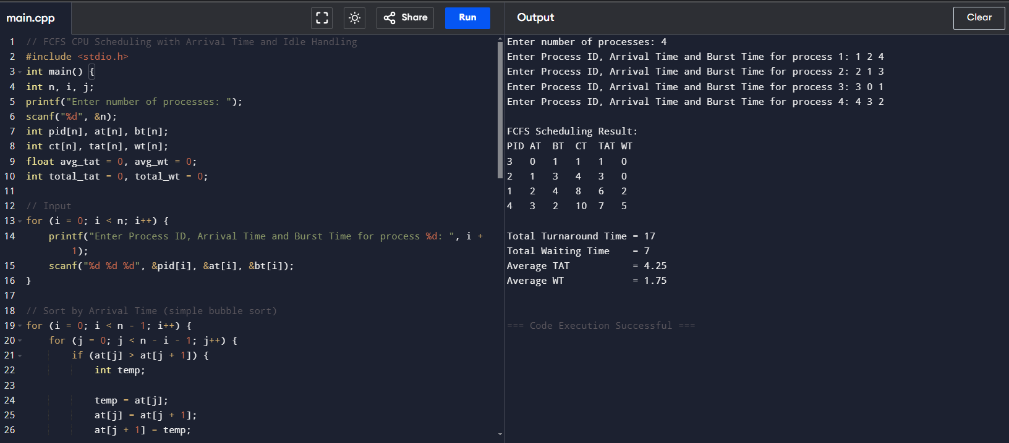

- Assignment Question: Implement SJF (Shortest Job First) Scheduling Algorithm
A process is a program in execution. CPU scheduling determines which process gets the CPU next.
The Shortest Job First (SJF) algorithm selects the process with the smallest CPU burst time next.
SJF can be:
- Non-preemptive → process runs until completion
- Preemptive (SRTF) → process may be interrupted if a new shorter job arrives
In this assignment, consider Non-preemptive SJF.

Problem Statement
Given the following processes:
Process | Arrival Time | CPU Burst Time
P1 | 0 | 8
P2 | 1 | 4
P3 | 2 | 9
P4 | 3 | 5
Task:
Implement the Non-Preemptive SJF Scheduling Algorithm to calculate:
- Completion Time (CT)
- Waiting Time (WT)
- Turnaround Time (TAT)
- Average Waiting Time
- Average Turnaround Time
- Gantt Chart

Code:

// Non-Preemptive SJF CPU Scheduling with Arrival Time and Gantt Chart
#include <stdio.h>
int main() {
int n, i;
printf("Enter number of processes: ");
scanf("%d", &n);
int pid[n], at[n], bt[n], ct[n], tat[n], wt[n];
int completed[n];
float avg_tat = 0, avg_wt = 0;
int total_tat = 0, total_wt = 0;

// Input
for (i = 0; i < n; i++) {
printf("Enter Process ID, Arrival Time and Burst Time for process %d: ", i + 1);
scanf("%d %d %d", &pid[i], &at[i], &bt[i]);
completed[i] = 0;
}

int current_time = 0, completed_count = 0;
int gantt_order[n];
int gantt_ct[n];
int gidx = 0;

// SJF Non-Preemptive Scheduling
while (completed_count < n) {
int idx = -1;
int min_bt = 1000000000; // large number

// find available process with smallest burst time
for (i = 0; i < n; i++) {
if (!completed[i] && at[i] <= current_time) {
if (bt[i] < min_bt) {
min_bt = bt[i];
idx = i;
}
}
}

if (idx == -1) {
// no process has arrived yet, CPU idle
int next_at = 1000000000;
for (i = 0; i < n; i++) {
if (!completed[i] && at[i] < next_at) {
next_at = at[i];
}
}
current_time = next_at;
continue;
}

current_time += bt[idx];
ct[idx] = current_time;
completed[idx] = 1;
completed_count++;

gantt_order[gidx] = pid[idx];
gantt_ct[gidx] = current_time;
gidx++;
}

// Calculate TAT and WT
for (i = 0; i < n; i++) {
tat[i] = ct[i] - at[i];
wt[i] = tat[i] - bt[i];
total_tat += tat[i];
total_wt += wt[i];
}

avg_tat = (float) total_tat / n;
avg_wt = (float) total_wt / n;

// Output table
printf("\nNon-Preemptive SJF Result:\n");
printf("PID\tAT\tBT\tCT\tTAT\tWT\n");
for (i = 0; i < n; i++) {
printf("%d\t%d\t%d\t%d\t%d\t%d\n", pid[i], at[i], bt[i], ct[i], tat[i], wt[i]);
}

printf("\nTotal Turnaround Time = %d", total_tat);
printf("\nTotal Waiting Time = %d", total_wt);
printf("\nAverage TAT = %.2f", avg_tat);
printf("\nAverage WT = %.2f\n", avg_wt);

// Gantt Chart
printf("\nGantt Chart (PID with completion times):\n");
printf("0");
for (i = 0; i < gidx; i++) {
printf(" | P%d | %d", gantt_order[i], gantt_ct[i]);
}
printf("\n");

return 0;

}

